EXERCISE – Financial Forecasting Using Recursion
1) What is Recursion?
Recursion is a programming technique in which a function calls itself to solve a problem. It divides a large problem into smaller subproblems until a simple condition called the base case is reached.
A recursive algorithm consists of two parts:
- Base Case – Stops the recursion.
- Recursive Case – Calls the same function with a smaller input.
Recursion makes the code simple, readable, and suitable for problems that can be divided into similar smaller tasks.
2) Objective
The objective of this exercise is to calculate the future value of an investment using a recursive approach based on compound growth. The recursive function repeatedly applies the growth rate until the required number of years is reached.
3) Recursive Method
public static double futureValue(double presentValue,
double growthRate,
int years) {

if (years == 0) {
return presentValue;
}

return futureValue(presentValue,
growthRate,
years - 1)
* (1 + growthRate);
}
4) Implementation
FinancialForecast.java
public class FinancialForecast {

public static double futureValue(double presentValue,
double growthRate,
int years) {

if (years == 0) {
return presentValue;
}

return futureValue(presentValue,
growthRate,
years - 1)
* (1 + growthRate);
}

public static void main(String[] args) {

double presentValue = 10000;
double growthRate = 0.10;
int years = 5;

double forecast = futureValue(
presentValue,
growthRate,
years);

System.out.println("===== Financial Forecast =====");
System.out.println("Present Value : " + presentValue);
System.out.println("Growth Rate : " + (growthRate * 100) + "%");
System.out.println("Years : " + years);
System.out.println("Future Value : " + forecast);
}
}
OUTPUT
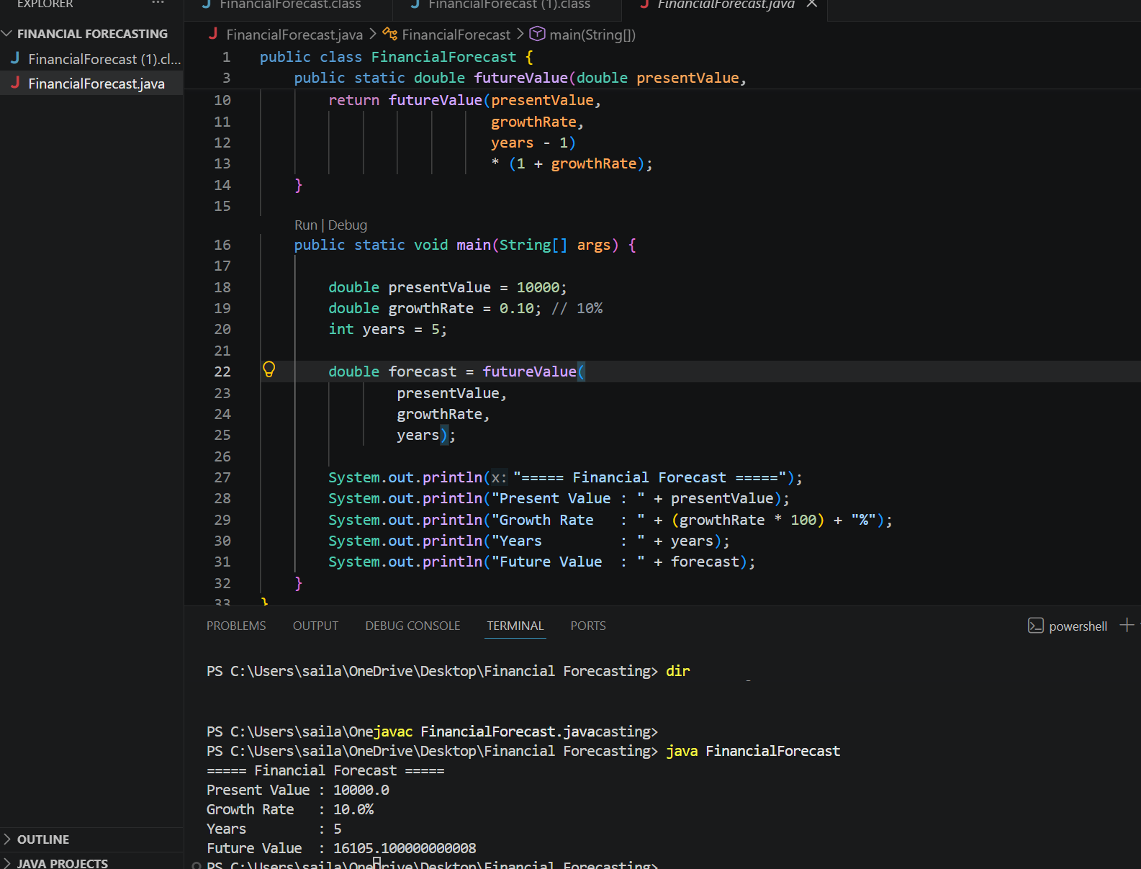
5) Analysis
Time Complexity
The recursive method makes one recursive call for each year until the base case is reached.
Time Complexity: O(n)
where n represents the number of years.

Space Complexity
Since each recursive call is stored in the call stack, the required space also increases with the number of recursive calls.
Space Complexity: O(n)

Recurrence Relation
For each recursive call,
$$T(n)=T(n-1)+O(1)$$where:
- T(n) = Time required for n years
- O(1) = Constant multiplication operation performed in each call

Optimization
Although recursion is simple and easy to understand, it uses additional stack memory.
The solution can be optimized by:
- Iterative Method – Uses constant memory (O(1) space).
- Fast Exponentiation – Computes the future value more efficiently with O(log n) time complexity.

Complexity Comparison
Method | Time Complexity | Space Complexity
Recursive | O(n) | O(n)
Iterative | O(n) | O(1)
Fast Exponentiation | O(log n) | O(log n)

Conclusion
This program successfully predicts the future value of an investment using recursion. It demonstrates how recursive functions can solve financial forecasting problems based on compound growth. While recursion provides a simple and elegant solution, iterative methods or fast exponentiation are more efficient for handling large forecasting periods.

